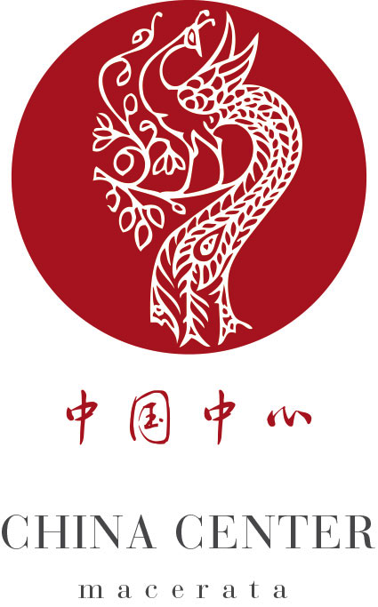

Application form
Summer school on Arts creativity innovation
ACADEMIC YEAR 2015-2016

To be sent to claudia.mengoni@unimc.it within: May 15th 2016

Name
Family Name
Male Female Date of birth (day, month, year) ____/____/____
Place of birth
Citizenship
Home address Town
Passport Number Expiry date
E-Mail Mobile phone
Home University
Field of study
Study year attended

Degree of knowledge of English language
Very good Good Fair Poor
Speaking Ο Ο Ο Ο
Listening Ο Ο Ο Ο

....................................
Signature

....................................
Date

